Kennel Calm for animals

Kennel Calm flower essence blend made especially for those dogs that are adjusting to a major shift in their lives. It is designed to aid in the transition to a new environment. It is for those dogs that are entering a new home with new owners. It is for those dogs who are entering a shelter for the first time. It is for animals who are having problems adjusting to an environment of any kind even if they have been there for a while. It is broadly applicable, designed to help in a variety of ways for any animal (including horses).
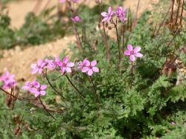
Erodium is helpful for excessive worry and aides in making a fundamental shift in perspective. Lilac provides support for the will power to move forward. Lilac is great for those who are ready to give up no matter what the cost and those with no motivation. Lilac can benefit those skittish, shrinking and/or anxious. Apricot-colored rose brings strength and balance. White rose is for sensations of instability and deep emotions of fear that might arise. A fifth and final essences works to balance the nervous system.*

DOSAGE: For an animal just arriving to the shelter take 4 drops 3x/day for 3 days. Put the drops in their water or on a treat or on their food or all three to be sure they receive a full dose. This also goes for animals who are having trouble adjusting to their new environment after being at the shelter for a while.
*The essences are simply distilled water and some brandy (used as a preservative). There are no drugs or chemical agents in flower essences. It can be safely used with any form of medical treatment. They are not intended to replace prescribed medical treatment.
Prepared by Alli Cutler flower essence practitioner and maker, 303.517.6152, www.floweressences.weebly.com

